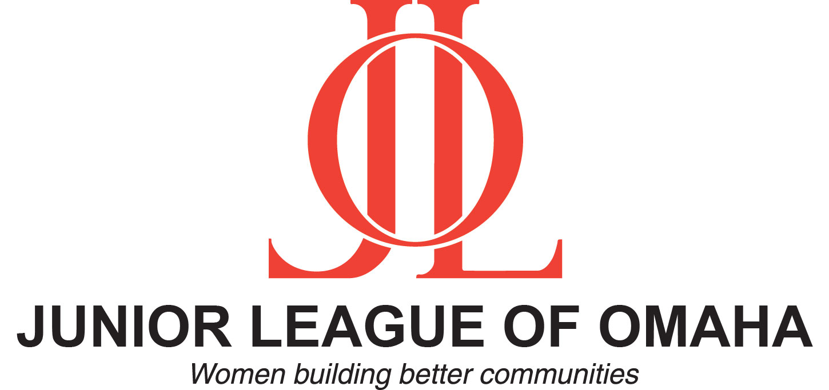
Grant Application
2017-2018

The Junior League of Omaha, a 501(c)(3) nonprofit corporation, is an organization of women committed to promoting voluntarism, developing the potential of women and improving the community through the effective leadership of trained volunteers.The Junior League of Omaha has donated more than $2 million and more than 1.4 million volunteer hours to the community, as well as awarded scholarships and community assistance grants.
The Junior League of Omaha will be accepting applications for mini-grants from local nonprofit agencies until January 31, 2018. These mini-grants are typically less than $2,000. The Junior League of Omaha prefers to fund projects that utilize the organization’s volunteer assets.
All requests must meet the following requirements:
- Receiving agency must be a 501(c)(3) nonprofit operating in Douglas County, Nebraska
- Projects must support and pertain to the needs, benefits, enrichment and enlightenment of women and/or children

The Junior League of Omaha will not provide funds for:

- Agency staff time
- Tickets or tables for benefits
- Fundraising activities
- Building funds or endowments
- Requests to fund individuals
- Trips or tours
- Research groups, including medical research
- Political matters
- Religious matters

Please provide the following information:

Organization Name: Click here to enter text.
Contact Person: Click here to enter text.
Title: Click here to enter text.
Phone: Click here to enter text.
Website Address: Click here to enter text.
Mailing Address: Click here to enter text.
E-mail Address: Click here to enter text.
Date of Application: Click here to enter a date.
Name of program/project for which funding is being requested: Click here to enter text.
Description of project: Click here to enter text.
Intended impact of the project on the Omaha community and specific populations served: Click here to enter text.
Is this a new or existing project? If existing, how long has it been in progress? Click here to enter text.
Are there other organizations that are partnering on this project? If yes, provide approximate dates, volunteer roles and/or funding. Click here to enter text.
How would funding from the Junior League be utilized to directly support this project? Click here to enter text.
Has your organization previously applied to receive support from the Junior League of Omaha? Click here to enter text.
Has your organization ever received funding or volunteer support from the Junior League of Omaha? Click here to enter text.
Is there any other information you feel would be important to share with the Project Development Committee? Click here to enter text.
Please submit the following items with your application:
- Documentation of your 501(c)(3) status
- List of your current board of directors
- Copy of your organizational budget and a copy of the budget for the project for which funding is being requested

Submit completed applications by mail or email to: Angela Cutler – Chair
Project Development Committee
Junior League of Omaha
12135 Pacific Street
Omaha, NE 68154
projectdevelopment@jlomaha.org

Timeline:

January 31, 2018 Applications must be received or postmarked by this date

Early March 2018 Project Development Committee reviews submitted applications and Junior League of Omaha Board of Directors approves recipients

Early April 2018 Applicants will be notified of grant awards

May 8, 2018 Award will be presented at the Junior League of Omaha’s Annual Meeting

